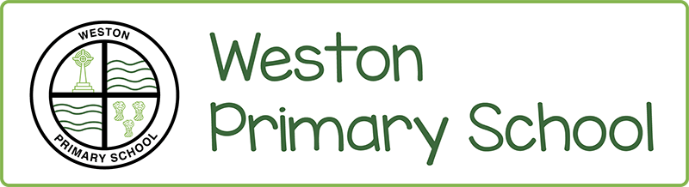

Public Duty equalities Statement September 2020 - 2021
We aim to be a close school community where everyone is treated fairly and with respect. We want everyone to reach their potential, and recognise that for some pupils extra support is needed to help them to achieve and be successful.
We are required to publish equality information as well as equality objectives, which show how we plan to reduce or remove particular inequalities or disadvantages. This information is reviewed and updated annually.
This duty has three elements. In carrying out their functions public bodies are required to have ‘due regard’ when making decisions and developing policies, to the need to:
- Eliminate discrimination, harassment, victimisation and other conduct that is prohibited by the Equality Act 2010.
- Advance equality of opportunity between people who share a protected characteristic and people who do not share it.
- Foster good relations across all protected characteristics – between people who share a protected characteristic and people who do not share it.
We welcome our general duty under the Equality Act 2010 to eliminate discrimination, to advance equality of opportunity and to foster good relations, and our specific duties to publish information every year about our school population; to explain how we have due regard for equality; and to publish equality objectives which show how we plan to tackle particular inequalities, and reduce or remove them.
The equality duty supports good education and improves pupil outcomes. It helps us as a school to identify priorities such as underperformance, poor progression, and bullying. It does this by requiring us to collate evidence, take a look at the issues and consider taking action to improve the experience of different groups of pupils. It then helps us to focus on what can be done to tackle these issues and to improve outcomes by developing measurable equality objectives.
We shall achieve this through:
- Implementing required policies and procedures regularly reviewing of school documentation Ensuring appropriate training for all our staff
- School assemblies and special events Through display in the school
- Our curriculum and interaction with all members of our school community
- Our communications, website and publications
- Our ethos and values
- Our daily interactions with parents and other visitors
- Appropriate oversight by school leaders and Governors Our identified school objectives
We shall continue to monitor and review our responsibilities in meeting our duty under the 2010 Equalities Act.
May 2021

