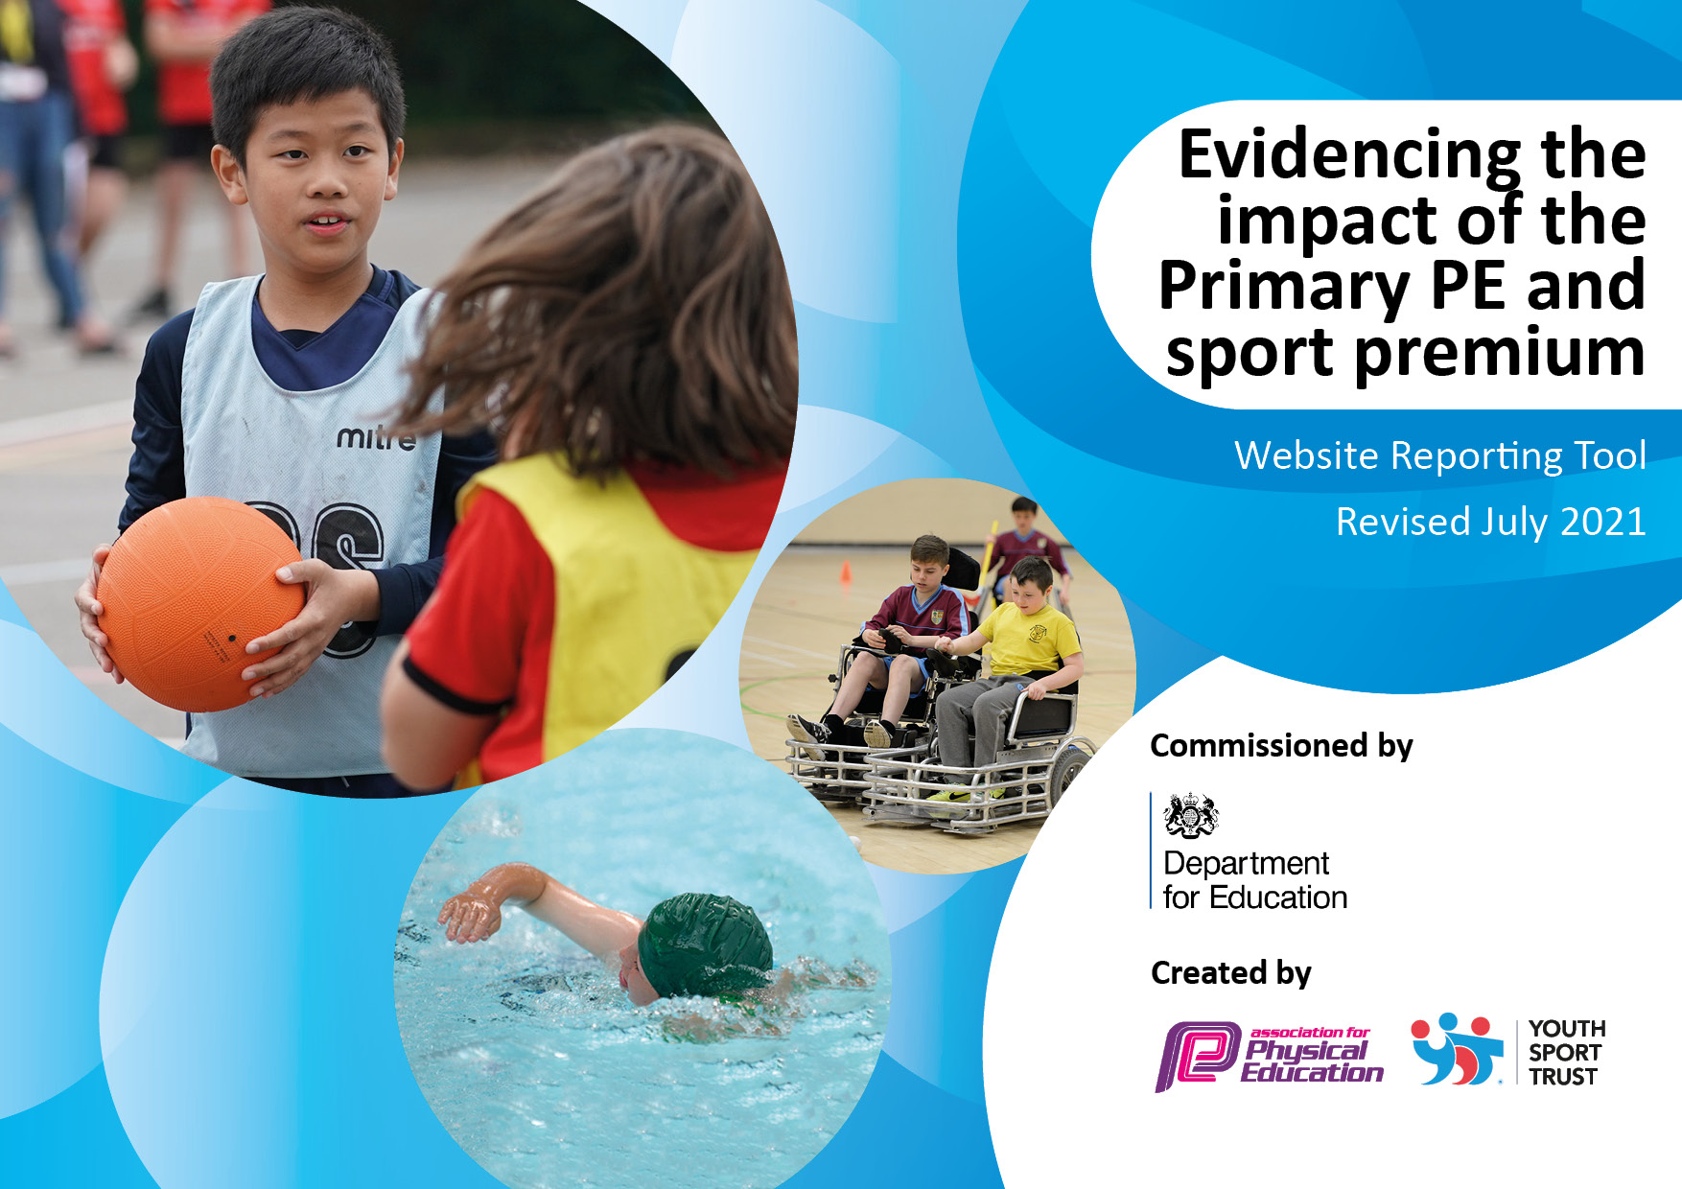
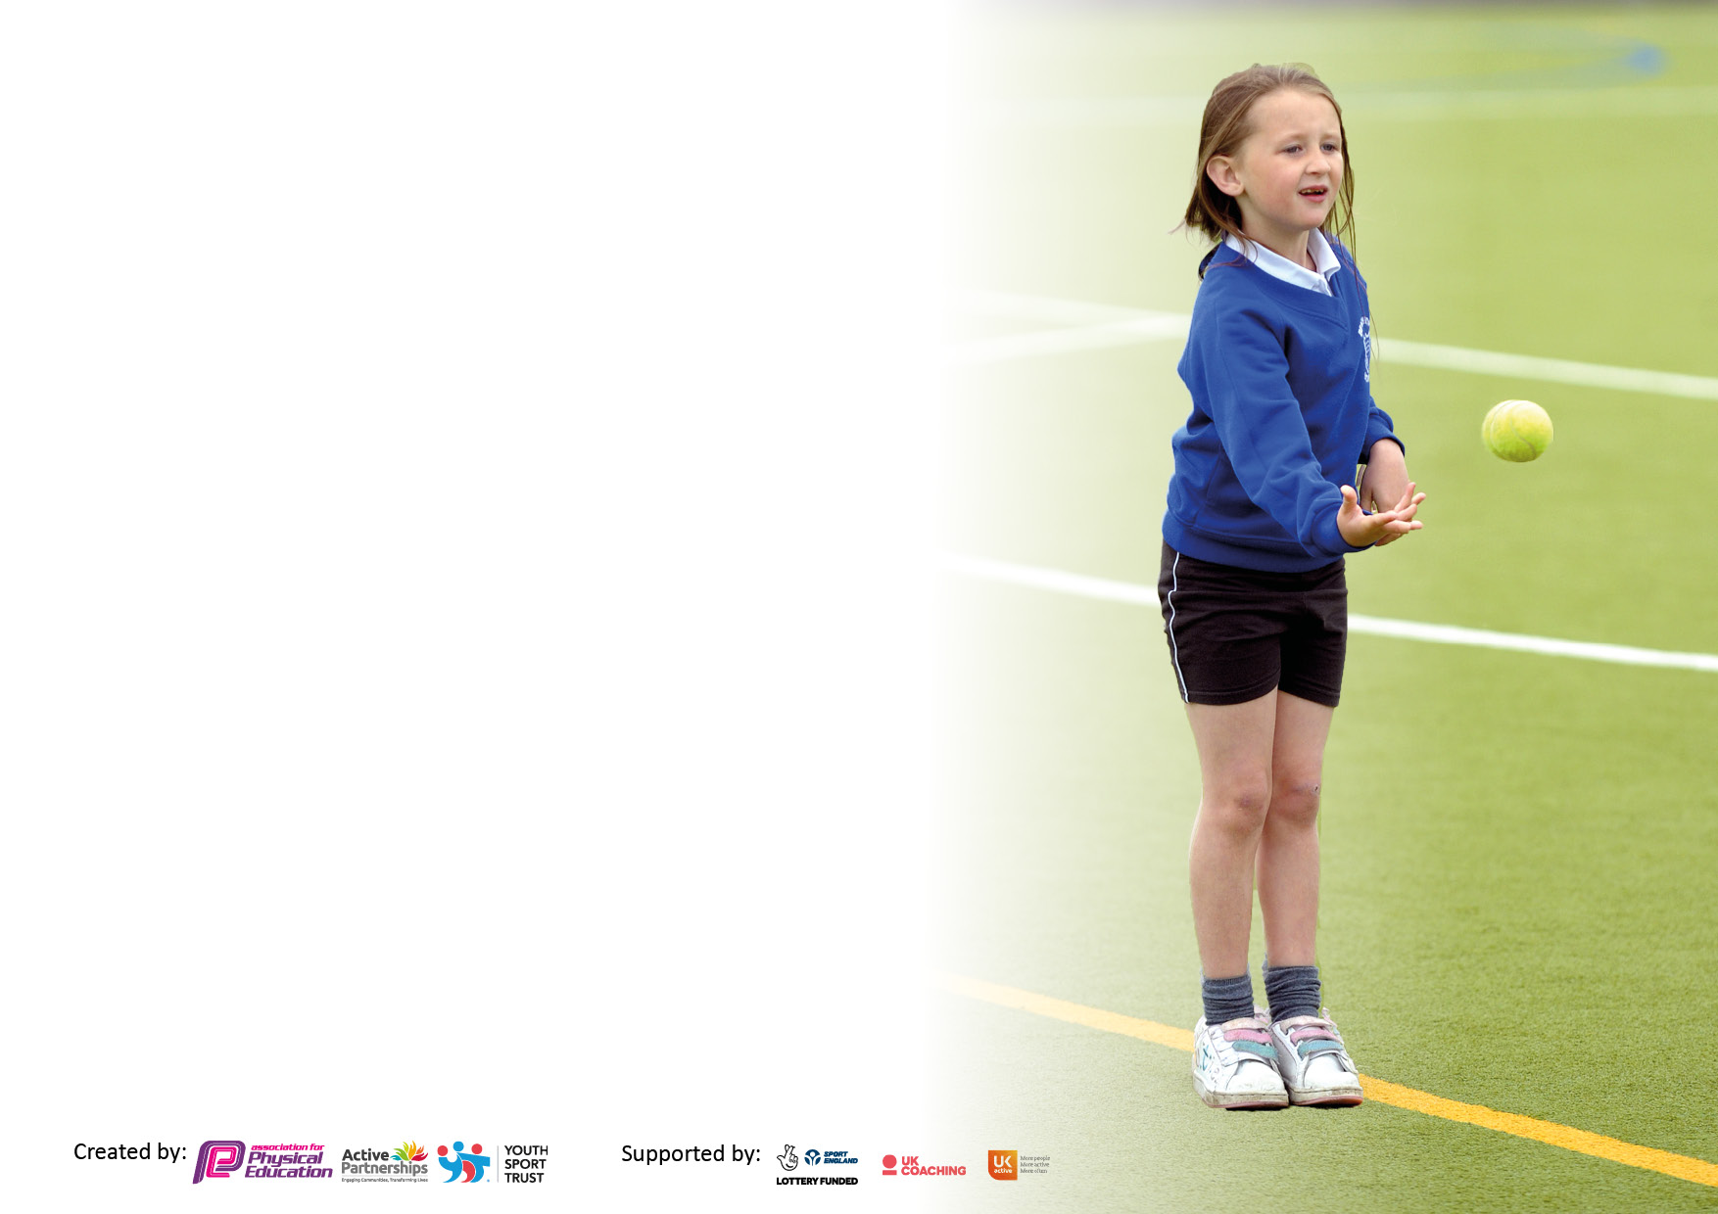

It is important that your grant is used effectively and based on school need. The Education Inspection Framework makes clear there will be a focus on ‘whether leaders and those responsible for governors all understand their respective roles and perform these in a way that enhances the effectiveness of the school’.

Under the Quality of Education Ofsted inspectors consider:
Intent - Curriculum design, coverage and appropriateness
Implementation - Curriculum delivery, Teaching (pedagogy) and Assessment
Impact - Attainment and progress

To assist schools with common transferable language this template has been developed to utilise the same three headings which should make your plans easily transferable between working documents.

Schools must use the funding to make additional and sustainable improvements to the quality of Physical Education, School Sport and Physical Activity (PESSPA) they offer. This means that you should use the Primary PE and sport premium to:

- Develop or add to the PESSPA activities that your school already offer
- Build capacity and capability within the school to ensure that improvements made now will benefit pupils joining the school in future years
- The Primary PE and sport premium should not be used to fund capital spend projects; the school’s budget should fund these.

Pleasevisitgov.ukfortherevisedDfEguidanceincludingthe5keyindicatorsacrosswhichschoolsshoulddemonstrate animprovement.Thisdocumentwillhelpyoutoreviewyourprovisionandtoreportyourspend.DfEencouragesschools to use this template as an effective way of meeting the reporting requirements of the Primary PE and sport premium.

We recommend you start by reflecting on the impact of current provision and reviewing the previous spend.

Schools are required to publish details of how they spend this funding, including any under-spend from 2019/2020, as well as on the impact it has on pupils’ PE and sport participation and attainment. All funding must be spent by 31st July 2022.

We recommend regularly updating the table and publishing it on your website throughout the year. This evidences your ongoing self-evaluation of how you are using the funding to secure maximum, sustainable impact. Final copy must be posted on your website by the end of the academic year and no later than the 31st July 2022. To see an example of how to complete the table please click HERE.
Created by: Supported by:

Swimming Data
Please report on your Swimming Data below.

Meeting national curriculum requirements for swimming and water safety.

N.B. Complete this section to your best ability. For example you might have practised safe self-rescue techniques on dry land which you can then transfer to the pool when school swimming restarts.
Due to exceptional circumstances priority should be given to ensuring that pupils can perform safe self rescue even if they do not fully meet the first two requirements of the NC programme of study
What percentage of your current Year 6 cohort swim competently, confidently and proficiently over a distance of at least 25 metres?  N.B. Even though your pupils may swim in another year please report on their attainment on leaving primary school at the end of the summer term 2022.  Please see note above | 80%
What percentage of your current Year 6 cohort use a range of strokes effectively [for example, front crawl, backstroke and breaststroke]?  Please see note above | 80%
What percentage of your current Year 6 cohort perform safe self-rescue in different water-based situations? | 80%
Schools can choose to use the Primary PE and sport premium to provide additional provision for swimming but this must be for activity over and above the national curriculum requirements. Have you used it in this way? | Yes

Action Plan and Budget Tracking
Capture your intended annual spend against the 5 key indicators. Clarify the success criteria and evidence of impact that you intend to measure to evaluate for pupils today and for the future.

Academic Year: 2021/22 | Total fund allocated: £14,826 | Date Updated:
Key indicator 1: The engagement of all pupils in regular physical activity – Chief Medical Officers guidelines recommend that primary school pupils undertake at least 30 minutes of physical activity a day in school |  |  |  | Percentage of total allocation:
 |  |  |  | %
Intent | Implementation |  | Impact
Your school focus should be clear what you want the pupils to know and be able to do and about  what they need to learn and to  consolidate through practice: | Make sure your actions to achieve are linked to your intentions: | Funding allocated: | Evidence of impact: what do pupils now know and what can they now do? What has changed?: | Sustainability and suggested next steps:
Engage at least 30% of the school in extra curricula physical activity/sport.  ALL classes from Y3-Y6 to go swimming for one term.  Struggling swimmers from y5/6 to go for extra swimming in summer 2 term. | Mr H to complete a pupil voice and offer “new” and different after school clubs as well as keeping popular clubs.  (As part of the LFC foundation CPD they will provide an after school club, 1 evening a week)  Autumn 1- Basketball Y3/4, Football Y5/6  Book extra session for summer 2 term.  Book extra session and school to pay for transport for these sessions. | £3,000 (as part of LFC foundation contract)  £2400  Approx £15 per 30 mins | Increased number of lunchtime and afterschool sports clubs including basketball, multisports, football, sports journalism  Year 4, 5 and 6 attended swimming lessons due to limitations of local swimming facilities.  All Y6 children swimmers. | To continue next year with inclusion of more sports  Continue with this offer
Key indicator 2: The profile of PESSPA being raised across the school as a tool for whole school improvement |  |  |  | Percentage of total allocation:
 |  |  |  | %
Intent | Implementation |  | Impact
Your school focus should be clear what you want the pupils to know and be able to do and about  what they need to learn and to  consolidate through practice: | Make sure your actions to achieve are linked to your intentions: | Funding allocated: | Evidence of impact: what do pupils now know and what can they now do? What has changed?: | Sustainability and suggested next steps:
Invest in new PE equipment to promote different sports.  Inclusion for all in PE at Weston Primary School. (PE lessons)  Replace PE equipment where needed. | In line with the new scheme of work, buy new equipment to allow the children to experience new sports: badminton, handball, parkour.  Create roles for children who can’t partake in PE for various reasons: referee, coach, tactician, commentator etc ……  Equipment bought to enhance PE and after school clubs. | £1000  £500 | New equipment purchased to support PE lessons including French Boules.  CPD and additional coaching to support PE Curriculum provided by PE Leader.  PE equipment replaced and made safe where necessary. | Continually reviewed  CPD to continue around another sport.  Continually reviewed.

Key indicator 3: Increased confidence, knowledge and skills of all staff in teaching PE and sport |  |  |  | Percentage of total allocation:
 |  |  |  | %
Intent | Implementation |  | Impact
Your school focus should be clear | Make sure your actions to | Funding | Evidence of impact: what do | Sustainability and suggested
what you want the pupils to know | achieve are linked to your | allocated: | pupils now know and what | next steps:
and be able to do and about | intentions: |  | can they now do? What has
what they need to learn and to |  |  | changed?:
consolidate through practice:
LFC foundation coaches to deliver staff CPD. Each teacher to receive 2 termly CPD slots per academic year. | Staff to work alongside LFC foundation coaches to develop their CPD journey. | £2400 (supply over for CPD) | Weekly support from LFC coaches for all staff enhanced quality of teaching and learning of PE. Pupil voice is positive regarding PE especially around range of sports on offer. | Investigate Gymnastic coaches and CPD for next academic year.
Key indicator 4: Broader experience of a range of sports and activities offered to all pupils |  |  |  | Percentage of total allocation:
Intent | Implementation |  | Impact
Your school focus should be clear | Make sure your actions to | Funding | Evidence of impact: what do | Sustainability and suggested
what you want the pupils to know | achieve are linked to your | allocated: | pupils now know and what | next steps:
and be able to do and about | intentions: |  | can they now do? What has
what they need to learn and to |  |  | changed?:
consolidate through practice:
Offer pupils a wider range of after school clubs:  Autumn 1- Basketball Y3/4, Football Y5/6 | After pupil questionnaire try and incorporate as many of these clubs as possible.  Create links with local clubs of these sports. | £ 120 | Pupil voice and feedback enhanced afterschool activities available at school. | Continue to gather pupil voice regarding PE to ensure children at the heart of decisions,

Key indicator 5: Increased participation in competitive sport |  |  |  | Percentage of total allocation:
 |  |  |  | %
Intent | Implementation |  | Impact
Your school focus should be clear | Make sure your actions to | Funding | Evidence of impact: what do | Sustainability and suggested
what you want the pupils to know | achieve are linked to your | allocated: | pupils now know and what | next steps:
and be able to do and about | intentions: |  | can they now do? What has
what they need to learn and to |  |  | changed?:
consolidate through practice:
To participate in a range of inter and intra schools competitions so children gain the opportunity to compete against a range of other children.  Transport to and from competitions  Supply if needed to cover teacher for competitions. | Buy into the Halton Sports Partnership and therefore have access to competitive sports. Links made with local sports clubs and information passed to children and parents.  - Y5/6 Runcorn football league Autumn 1. | £500  Potential £200 per trip  Potential £190 per day | Football teams took part in local competitions.  Supply cover for PE lead to attend competitions alongside TA and first aider. | Need to extend inter school competition further for other sports.  Continue to ensure adult child ratios are correct and safeguarding including health and safety remains a priority.

Signed off by
Head Teacher: | HL Pitt
Date: | 13th July 2023
Subject Leader: | S Helsby
Date: | 13th July 2023
Governor: | R Houghton
Date: | 13th July 2023

